MyLearnMate: Interaction Techniques as a Support in Teaching and Learning of the Science and Mathematical Notions through a Computer Based System
Sneha.D.L  BMSCE,  Basawana Gudi,  Bangalore, India.  sneha.dabbadi@gmail.com |  |  |  |  | Vikramaditya Jakkula  Washington State University  EME 206, Spokane Way  Pullman, WA 99164  vikramaditya@wsu.edu

ABSTRACT
Computer based education systems are increasingly growing to support students learn and practice academic concepts that were previously only taught through black board mechanisms at schools in developing countries. Enabling students to learn by computer assisted interactive mechanisms is becoming extremely important in the current context. [10] The growing number of interactive computer based systems and applications connected to the Internet are causing Internet traffic to grow rapidly. Educational interactive systems have developed from simple devices which allowed students learn alphabets, to intelligent systems today which can analyze huge patterns.
As the growth of computers and technology advancing at this level, it raises the need to analyze what and how the teaching strategies should be followed and how these advances of technology should be made use of to incorporate a system of educational software.
This paper presents a description of methods and a discussion of results of the implementation of a computer system which works to meet the individual needs of the student, which is easy to use and learn with interactivity uniquely provided by touch and drag-and-drop mechanisms about the science and mathematical portions, worked with Indian students who were attending their primary school (children of 5-11 years of age).

Permission to make digital or hard copies of all or part of this work for personal or classroom use is granted without fee provided that copies are not made or distributed for profit or commercial advantage and that copies bear this notice and the full citation on the first page. To copy otherwise, or republish, to post on servers or to redistribute to lists, requires prior specific permission and/or a fee.
CSCW 2012, February 11–15, 2012, Seattle, Washington.
Copyright 2011 ACM XXX-X-XXXXX-XXX-X/XX/XX...$5.00.
AUTHOR KEYWORDS
Education, HCI, Learning, GUI, Design, Mathematics, Science, Teaching Tool, computer based learning, Touch, Drag-and-Drop.
GENERAL TERMS
Education, Interactive Learning, Design, Teaching, Touch Technology.

ACM CLASSIFICATION KEYWORDS
Information interfaces and presentation (HCI):

INTRODUCTION
The motivation for MyLearnMate is to integrate all features of Ink, touch and drag-and-drop mechanisms into modern presentation software and thus enhance classroom teaching through computer based system. It preserves all good properties of the traditional class room teaching, including easy questioning and answering mechanisms, while providing distance learning as a pleasing side-effect. MyLearnMate is therefore just a computer based education system, but a state of the art one, that combines the traditional advantages of learning by touch interactivity and an advantage of distance education software.
The main reason for the failure of present day educational systems is that the individual needs of each student to sustain a successful learning process are essentially ignored in traditional classroom practice. Transformations that purports to accelerate the solution of these problems requires the support of educational technology that improves learning outcomes and provides motivation to learn by making teaching and learning more interactive and fun, which can be achieved by using touch technology thus making learners more involved in the subject matter. This research also focuses on the fact that even whether the system is attractive and fun to use can make a significant difference in teaching and learning.

Basic Education for students of primary schools to develop cognitive structures in the mathematics and scientific areas to successfully face the academic demands of the next rung of the school system is becoming extremely important in the current context.

It is well known that the children’s cognitive skills develop over time, there is a need for the next generation HCI techniques to consider the cognitive challenges that face the young learners.[3,8]
New HCI techniques will need to revisit the developmental cognitive skills of children especially of age ranges (5 to 12). Also active involvement of the students with the learning material is very important, which can be best achieved when the user interface is intuitive and unobtrusive, ensuring that children’s concentration is maintained throughout the activity. Thus, there is need for a new technology in HCI which constantly focuses to work on improving the cognitive skills of the students and making them more involved in subject matters through intuitive interface mechanisms.

In this paper, we introduce a proposal developed by teaching a computer system with interactive activities using touch technology. The design of the proposed activities is based on observations and a previous study with teachers and students of primary school from first to fifth grade on the key topics such as addition, subtraction, that begin in elementary school and provide a basis for later concepts such as force, work done, geometry etc. The design of these activities is based on the studies realized by researches that have worked on these topics, such as researches in the science, mathematics, computation and educational technology.

RESEARCH PROBLEM
Research goals are to identify whether the process of teaching mathematics and science designed by a computer system using drag-and-drop (Ink features) and touch technology, allow the students (of 5-11 years) to build the key concepts of their curriculum, and develop qualitative thinking skill to answer the questions of mathematics and science more productively when compared to class room learning mechanisms.
To identify ways to enhance teaching mechanisms that can make the process of learning and teaching better when compared to present methods of teaching.
The objectives of this research include:
- Identify and promote ways in which touch technology can enhance the reach and quality of education in primary schools.
- Bring about pedagogical improvements and learner-centered teaching through the computer systems.
- Provide qualitative thinking that allows students to perform mathematical and scientific operations through touch interactivity by using the computer system.

Main objective of this research is to present teachers with the software system that is easy to use and to enhance their teaching process. MyLearnMate Learning System is a full-featured teaching and learning system, whose feature-set and proven performance stand as the solution for the above mentioned objectives. Some of the many capabilities offered by the system include learning by touch, ink and Drag-drop interactivity, self assisted testing and self tracking of student performance and more.

METHODOLOGY
The methodology is based on the qualitative surveys conducted to gather the new curriculum data from teachers and schools with a particular focus on the implementation of the new mathematics and science syllabus for the primary school. The key mathematical concepts are taught by providing individual interactivity. [2, 11]

For example: The student logs into the system and practices arithmetic operations through MyLearnMate system. The student can test his knowledge after thorough practice through individualized interactivity provided by MyLearnMate. Thus taking self tests, helps students to analyze their understanding of concepts and to make a note of their performance.

Giving importance to the fact that science is better understood when practically tested and analyzed with real world examples and methods, key scientific concepts such as Force, Work done, Eclipse etc. are taught by making use of innovative techniques to enhance the practical knowledge of primary students through touch technology.
MyLearnMate is an activity and competency-driven program designed to provide students with the primary school knowledge and skills critical to understand and face key academic challenges. MyLearnMate offers a self-paced learning experience, enabling all students to accelerate through the program at a personalized rate.
MyLearnMate content, available via Internet
Is cost effective technology that is modular and flexible, enabling students to learn and practice exercises covering a wide range primary school topics.

Through touch based learning activities and self assisted training mechanisms, MyLearnMate offers the benefits and advantages of blended learning — an approach that combines uniquely interactive touch and drag-drop mechanisms with self assisted training. MyLearnMate Content provides students the foundation required for future careers or further school educational needs.

Methods:
This computer based system is developed from the scratch to have a user interface uniquely tailored to pen, stylus, mouse and touch input.

Touch interface:
The use of computers in the field of education is being implemented almost in every institute now. But, the use of touch technology to enhance student’s education skills is something new to invest time in. The main reason for using touch as a medium of interaction is to make learning easy, fun and real. The uniquely tailored touch interface takes input from the user through finger, stylus or Microsoft mouse.
Following are some of the innovative methods in which touch is being used as a medium to teach and learn some of the key academic concepts for primary school students.
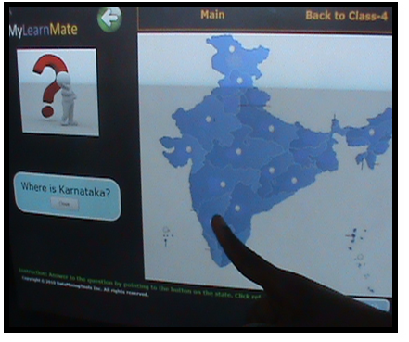
Figure 1: Touch Interface.
Figure-1 shows one of the methods where the student learns to map through MyLearnMate system.
Learning new words by Touch
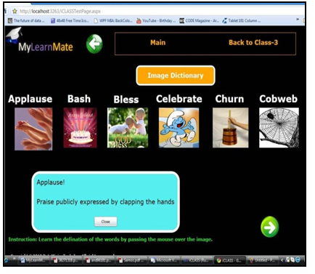
Figure 2: Image Dictionary.
Figure-2 shows the activity that is mainly designed to improve the vocabulary knowledge of the students. The student has to choose the image he wants to learn through touch, and the computer system pops-up the definition of the word and gives its usage.
Teaching the concept of Force through Touch.
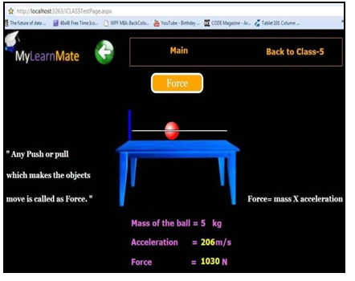
Figure 3: Force
Figure-3 explains a method on how the concept of Force is taught by creating a scene where the students experience the actual force and understands the meaning of its definitions and formulae in an intuitive manner. The student drags the ball on the table and observes the changes in the values of acceleration and force as he applies force in order to move the ball. Thus, this activity helps the student understand the concept of Force by experiencing it practically.
This kind of interactive answering mechanisms introduced in this computer based system where the student labels human body parts and maps the continent and states by touch etc, turned out to be very successful as the students showed great autonomy in learning and answering the questions just by touch.
Learning the Human Body Parts by Touch.

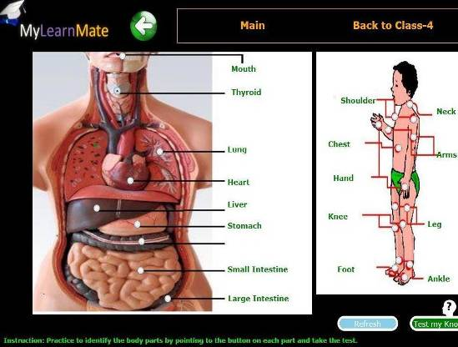
Figure 4: Human Body.
Figure-4 explains a method on how the labeling of human body parts is taught by creating an interactive mechanism. Students learn to label the organs by touch interfaces. The computer based system displays the name of the organ when the student points at the organ. Thus, this activity helps the student understand and learn to label organs easily.
This kind of interactive answering mechanisms introduced in this computer based system where the student labels human body parts and maps the continent and states by touch etc, turned out to be very successful as the students showed great autonomy in learning and answering the questions by touch.
Benefits of Touch based Interactivity:
Touch based interactivity makes learning easy and faster as it brings the real world interface into picture.
Using touch technology in education has the following advantages:
- The mouse is replaced by a pen-like input device and the use of the keyboard is avoided as much as possible.
- Every student benefits from learning by the “personal touch”. Thus, learn practical concept of geometry and science with the simple swipe of a finger.
- Touch provides paperless, environment-friendly rich media information output
- Using touch interaction, student response was higher in less time.
- Ease of use-For those students who are unfamiliar or uncomfortable with computers, touch technology is easy to use. Students can access and learn information faster. (no computing knowledge needed to control a touch screen computer)
Drag and Drop:
Effective utilization of drag and drop mechanism is being made in order to make concepts like matching the objects, names, shapes, etc easy and fun to learn. Drag-and-drop techniques turned out to be very innovative and effective on the student side as the students had to involve themselves in pointing to the right answer and drag it to match right object, this activity focused the student’s concentration on the material to be learned. Following are some of the methods in which drag-and-drop techniques are being used as a medium to teach and learn some of the key academic concepts for primary school students.
Learning Days and Months by Drag-and-Drop.
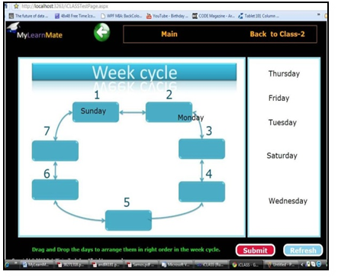Figure 5: Week-Cycle.
Figure-5 shows a method where students are taught the concepts of days and weeks in a very innovative manner by making use of week-cycle. The student has to drag and drop the days in order to arrange them in the right order of the week-cycle. This kind of drag and drop practice helps the students in learning days and months in a very interesting and easy manner.

Understanding the concept of Eclipse by Drag-and-Drop.
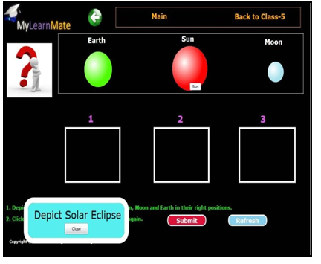Figure 6: Eclipse.
Figure-6 shows the activity of understanding the concept of Eclipse through the Drag-and-Drop mechanism.
The student drags and drops the planets in right order to depict the eclipse. This kind of drag and drop practice helps the students learn the difficult concepts easily.
Ink features:
Microsoft ink is used as a medium to teach and learn writing concepts like practicing alphabetical work sheets, numerical work sheets, cursive writing etc. The students get to practice on the work sheets using the ink through fingers, stylus, pen or mouse input. Thus, this mechanism makes writing practices more fun and easy.
Cursive writing though Ink.
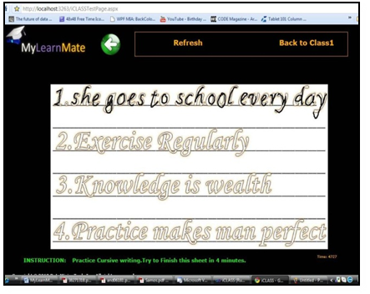Figure 7: Cursive Writing using Microsoft Ink.
This activity is designed for students in order to practice Writing alphabets, numbers and sentences directly on the computer using the Microsoft ink.
Paint using Microsoft Ink.
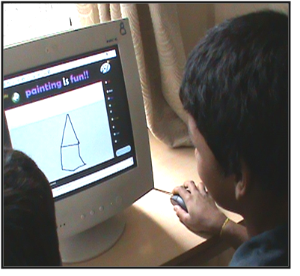Figure 8: Paint using Microsoft Ink.
This above figure shows a student painting using Ink features. The student’s showed great interest in painting using ink strokes and colors.
Benefits of Drag-and-Drop mechanisms:
Drag and Drop feature maximizes the learning process and helps students to learn by self engaging. Drag and Drop is a really useful mechanism used to take away the monotonous approach of learning geometry, concept of Force and more.
Example: The difficult concepts such as Force and Eclipse can be understood easily practically by drag-and-drop.
Computer-assisted self-testing:
This computer system not only teaches students the concepts statically, but also lets them practice a number of times in a fun and practical way and by allowing the students self test their knowledge. Computer-assisted self-testing is based on the fact of the interactive art design that interactivity engages users, and enhances user self-reflection.

Benefits of Computer-assisted self-testing:
The advantages of computer-assisted learning are as follows:
- Computer based self-training is a fairly new approach to training and many students are finding that they enjoy it a lot more than more traditional methods of testing their knowledge.
- MyLearnMate self-assisted training advantage is seen for example in self-paced and self-directed learning and increased motivation. It is useful as it can lead to more structured learning and can support training in evidence-based decision-making.
- MyLearnMate formulates randomized questions, which exposes students to answer unique questions each time.
- In computer-assisted self testing, data can be checked without delay. A well implemented data collection program performs validity checks to correct the given response and generates the result without any delay.

EXPERIMENTATION AND RESULTS

Study Overview:
Two primary schools participated in the survey that was conducted during July, 2010 in India to get the response and feedback about MyLearnMate educational system from teachers and researchers who have worked with these topics.
The following are the survey results being analyzed based on the student’s performance after practicing the science and math concepts using the MyLearnMate computer based system.
Student Response:
The students showed great interest in working with the touch interfaces of the computer system and had autonomy in the resolution of tasks. In figure 9, we illustrate the student response for the questions to solve math and science problems after practicing through the computer based system.
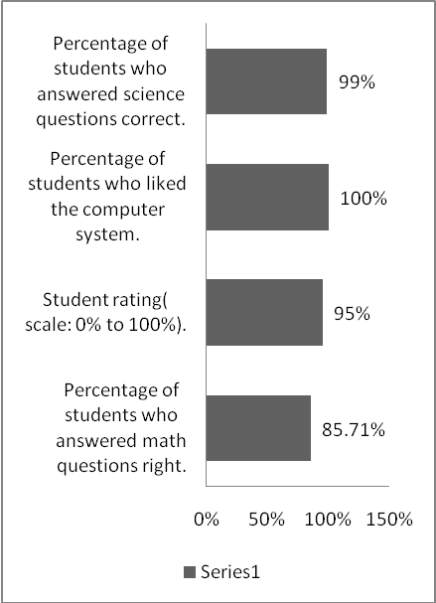
Figure 9: Students performance chart.
Ranking:
We asked the teachers and students to give ranking for the MyLearnMate methods being used according to their preferences.

The following chart shows the ranking based on preferences by the participants (teachers) based on how effectively MyLearnMate techniques helped students learn the math and science concepts better and quick when compared to class room practice.

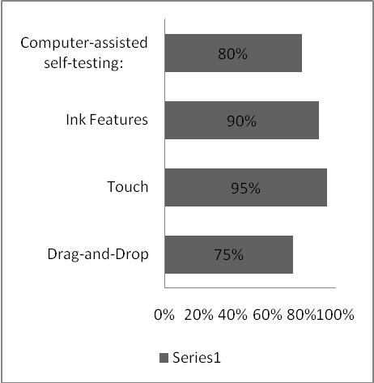
Figure 10: Preferences chart.

From the chart, we can see that learning by touch interfaces had the highest rankings where as the other techniques had almost similar feedback. After analyzing the results of the study, we found that student learning process was better through computer based MyLearnMate system when compared to the class room practice.

The Positive Aspects of MyLearnMate on Students:
- MyLearnMate software is available on Internet so that students can practice and learn from distant places.
- As compared to traditional black board mechanisms, time spent in copying supplementary material questions and then answering is avoided in MyLearnMate learning mechanisms. So that they are better able to concentrate on the essential concepts “in real time”.
- The use of drag-drop and touch interfaces makes the process of learning interesting and easy.
- Students can go back to any key concept and practice as many number of times.
- The students can test and analyze their performance on spot.
- The students can actually find out the practical application of the theory that they are learning in the classrooms.
- Drag-and-Drop, touch mechanisms and individualized authority especially designed to improve the learning concepts when applied to educate the students, act as stress reliever for them. The students are relieved of their stress besides the learning process is greatly improved.

Pros from the point of view of the teacher:
- Questions and comments from the students are more frequent than with blackboard lectures.
- The amount of material covered did not decrease when they taught the same course using transparencies in the past, but the amount of time spent on explanations and discussions did.
- The ease of teaching afforded by the touch and Ink based interactivity is a great incentive in order to increase the interest of students in learning.
- Using MyLearnMate techniques to teach students is a lot of fun, and this fun seems to rub off on the students side as well as they showed great interest in learning through this system.
- This software helps teachers to record and check the performance of the students on spot and on the basis of which the students can be suggested different ways to improve their performances.
- MyLearnMate software can be used by the school management to give students the real time problem solving environment. By this the students can learn the practical use of the theory lectures that they are receiving in the class room.
- The students can be given the assignments to practice through MyLearnMate. By this the curriculum is made interesting and also the active participation of the students contributes a lot in the development of their personality.
Thus the results of this Practical experimentation show the following advantages of MyLearnMate system:
- MyLearnMate has benefits when compared to the traditional classroom teaching especially the possibility to test and analyze performance on spot at the rate of train of thoughts.
- MyLearnMate improves learning by enabling the students to practice and learn using MyLearnMate from the Internet. Thus, adding the benefit of distant learning.
- MyLearnMate helps students find the practical application of theoretic concepts they learnt in school.

BENEFITS OF MYLEARNMATE SYSTEM:
Using MyLearnMate technology for education has many benefits. Some of these can be summed up as follows:
- This kind of computer based educational system stands as a solution for providing education at primary school level using the most sophisticated technologies and answers the issues that were raised in the beginning.
- Techniques chosen affected the way users carried out the activities. All the techniques used in MyLearnMate systems benefitted primary students to learn faster and easier. The ease with which many students participated in the survey and showed enthusiasm in solving the science and math problems with MyLearnMate system showed that this kind of educational systems definitely benefits the students and more such systems should be developed in the future.
- MyLearnMate is a software system for both classroom teaching and distance learning. The basic metaphor that MyLearnMate uses is the touch, drag-and-drop interfaces work as ideal teaching tools in educational system.

Benefits of MyLearnMate on Teachers:

- MyLearnMate Software System is a robust class/lab learning system providing teachers with the real-time tracking of student performance and their improvement progress. Assessment and testing tools provide quantitative evidence that learning is taking place.
- Easy authoring of practice tests and assignments.
- MyLearnMate provides easy and simple installation of the system in a classroom lab or school server.
.
Benefits of MyLearnMate on students:
- MyLearnMate software system serves as the students’ learning dashboard, providing the real-time access to content, assignments, tests and more.
- Personalized approach improves skill levels by accommodating individual learning styles.
- MyLearnMate provides rich interactive mechanisms for learning content and calls for continuous student involvement in the learning process, thereby increasing knowledge retention.
- MyLearnMate Content is the best available solution for making the process of teaching better with its proven track record for student success.

Thus, the evaluations confirm MyLearnMate to be a beneficial and usable system for teaching primary school students.

CONCLUSION ON IMPACT AND EFFECTIVENES:
The conclusions are intended to answer the issues raised at the beginning. This project has been intended to support students in consolidation of mathematical and scientific concepts practically using the touch technology. Through the results, we can say that the activities designed to support education, are best imparted with practical examples and methods for the students in the consolidation of the various essential and key academic concepts and skills using the computer system, because the students showed great interest in working with the touch interfaces of the computer system and had autonomy in the resolution of tasks.
It is scientifically proven that the learning process is much more improved and the grasp of the subject is more if the theory is applied practically. [11]. Using MyLearnMate, students develop self learning and assisting skills which is very essential in present situation. Learning is a continuous process. The students can thus slowly be made to understand their curriculum concepts by practicing through MyLearnMate technology at their own pace.

MyLearnMate software system is portable, interactive, and free to use. Following are the best reasons for using MyLearnMate in education.

- Free of cost: MyLearnMate software system is available free of cost on Web.
- Ease of Use: The Touch, Ink and Drag-and-Drop interfaces of MyLearnMate software system makes it very user friendly, and can quickly be learned by even the youngest students. It is intuitive, responsive, and highly motivating
Using MyLearnMate software system in the classroom has many advantages. They are cost efficient and easy to use. Student interest and motivation to learn is high when using this software system.
A meta-analysis conducted on elementary school students, reported that computer-based education through the use of touch technology has generally had the following positive effects on the achievement of elementary school students.
- On an average, about 85% of the students could perform arithmetic operations faster after practicing through these computer systems.
- Students could learn more in less time when they received computer-based instruction and when they had to answer just by touch.
- Maximized student reflection and encouraged progressive taught, taking multiple perspectives, and independent thinking.
- Students who practiced geometry and other scientific concepts through the touch based interactive computer system showed better problem solving skills than students who learnt concepts and definitions through classroom instructions only.
- Graphical drag-and-drop mechanisms and touch interactivity will speed up the production of students.
Thus, the experimental evaluations confirmed MyLearnMate to be a beneficial and usable system for teaching.

REFERENCES
- Becker, Henry Jay (1994) Mindless and Mindful use of Integrated Learning Systems. International Journal of Educational Research, Vol. 21, No. 1, 65-79.Oxford: Elsevier.
- Engelbrecht, J.; Harding, A. (2005a). Teaching undergraduate mathematics on the internet. Part 1: Technologies and Taxonomy. Educational Studies in Mathematics,58, 235-252.
- Jakob Nielsen. Advances in Human-computer Interaction, Vol. 5
- John Schacter, Ph.D: The Impact of Education Technology on Student Achievement: What the Most Current Research Has to Say.
- Lim, C. K. (2001). Computer self-efficacy, academic self-concept, and other predictors of satisfaction and future participation of adult distance learners. American Journal of Distance Education, 15(2), 41-51.
- Mary Beth Rosson, John Millar Carroll. Usability engineering: scenario-based development of human-computer interaction
- Nguyen, D. M., y Kulm, G. (2005). Using Web-based Practice to Enhance Mathematics Learning and Achievement. Journal of Interactive Online Learning, 3, 3.
- Richard Harper, Tom Rodden, Yvonne Rogers and Abigail Sellen(2020). Being Human: Human computer interaction in the year 2020
- Ronald M. Baecker , Jonathan Grudin , William Buxton, Saul Greenberg(2000). Readings in human-computer interaction: toward the year 2000
- Savin-Kachala, J. (1998). Report on the effectiveness of technology in schools, 1990-1997. Software Publisher’s Association.
- Wenglinsky, H. (1998). Does it compute? The relationship between educational technology and student achievement in mathematics. Educational Testing Service Policy Information Center.

